What you should know.

Contractors and

Permits

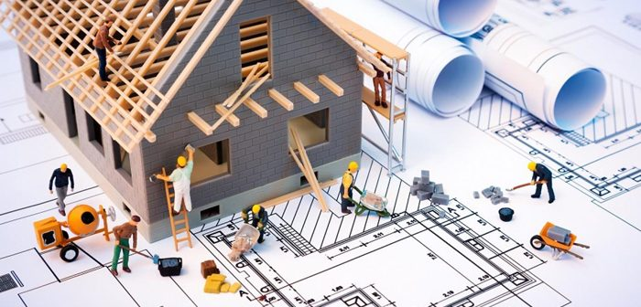

Contractor License Limits

Failure to Comply:
Any individual who is engaging the services of a contractor must make sure that the contractor does indeed have a current South Carolina State License in the given discipline, and the license limit either meets or exceeds the contractual agreement.
If you are unsure as to your contractors license limit, please see South Carolina's Department of Labor, Licensing & Regulation website for contractor licensing limitations and further information.
Failure to meet these requirements will result in fines being imposed on the owner and contractor. This fine will include all court costs.

General Contractor Limits:
Contractor License Limits - General Contractors
BD1 | $50,000.00
BD2 | $200,000.00
BD3 | $500,000.00
BD4 | $1,500,000.00
BD5 | Unlimited

Commercial Sub-Contractor Limits:
Contractor License Limits - Mechanical Contractors
M1 | $17,500.00
M2 | $50,000.00
M3 | $100,000.00
M4 | $200,000.00
M5 | Unlimited

Residential Contractor Limits:
While there is no limit imposed on a South Carolina State licensed residential contractor, a residential contractor can only engage in residential work.

Specialty Contractors:
Specialty contractors license limit is $5,000.00 with the exception of a specialty contractor who has posted a $10,000.00 assurance bond. These contractors can only engage l work, this does not entitle them to oversee job completion.

Grandfathered Contractors:
These contractors are not licensed by examination. They had been performing their trade prior to the State of South Carolina requiring contractor’s licenses. The limit of these type of contractors license is $5,000.00.

General & Mechanical Contractor Questions Regarding Compliance Issues:
How do I file a complaint?
You may file a complaint online or you may download a complaint form and mail the form to the Office of Investigations and Enforcement to address listed on it.
If an owner of a commercial/industrial plant is adding on or remodeling, can he use his own employees (i.e., maintenance staff) to do the work?
No, not if the work exceeds $5,000. If the plant owner has an employee and the employee has a commercial license, he could contract with the plant to do the work. The plant owner cannot tell him not to meet code to save money. He must obtain a building permit under his license and be responsible for all work performed. If the licensed employee wanted to hire plant employees or allow them to do the work or perform work that is covered under his license, he would have to supervise their work and be responsible for their work.
Did the Contractor's Board adopt the South Carolina Residential Construction Standards?
Yes-The South Carolina Residential Construction Standards apply to any Contractor's permit pulled for Residential Construction after January 1, 2015. The standards were revised and re-adopted by the Board on October 13, 2022. The Residential Construction Standards are guidelines used in analyzing initial complaints along with the Contractor's Board's statutes and regulations.
Who can install Boilers in SC?
The Board's present position as of October 22, 2020, is that mechanical contractors with the Heating-HT subclassification can install boilers. Therefore, boiler work can be performed by either a general contractor with Boiler Installation-BL or a mechanical contractor with Heating-HT. Further clarification may be forthcoming.
What license is required to install Natural Gas Piping?
Acting upon a request by the Contractors' Licensing Board Staff, an interpretation by the South Carolina Contractors' Licensing Board, at its July 21, 2016 meeting, instructed staff that to perform natural gas piping in commercial installation, alteration or repair, an entity must hold a South Carolina Mechanical Contractors license with a plumbing (PB) classification. A person holding an air conditioning (AC) heating (HT) or package equipment (PK) license may install natural gas piping for the HVAC equipment.
Can a licensed mechanical contractor install or service LP Gas systems?

No, any person engaging in the business of installing, servicing, repairing, adjusting, disconnecting, or connecting appliances and equipment to liquefied petroleum gas systems or containers, must be properly licensed with the South Carolina LP Gas Board

What are the requirements to do work in the City of Mullins?

Permit Requirements
- All commercial work.
- A permit is required for most residential work / improvements (excluding some interior remodeling including painting, doors, papering, tiling, carpeting, cabinets, counter tops, and similar finish work).

Commercial and Residential Contractor requirements.
- A City of Mullins Business License is required
- A South Carolina State License is required for any of the following:
  - General Contractor (Residential or Commercial work over $5,000)
  - Residential Home Builder (Residential work only, no limit)
  - Specialty Contractor (Residential work only; not to exceed $4,999.99 or be bonded through SC Labor, Licensing, and Regulations [LLR])
Electrical, Plumbing, Gas, and Mechanical Contractors requirements.
- A City of Mullins Business License is required
- A South Carolina State License is required for any of the following:
  - Specialty Contractor (Residential work only; not to exceed $4,999.99 or be bonded through SC Labor, Licensing, and Regulations [LLR])
  - South Carolina Mechanical Contractor's License (Required for Residential and Commercial work)
  - For gas work; Mechanical Plumber or Specialty heating, ventilation, and air conditioning (HVAC) contractor license is required for any gas work (including putting pressure on a gas line)

Work on Your Own Property
A homeowner who owns his own home and lives there and is performing work himself may be issued a permit (after completing a Disclosure Statement and having it recorded at the Register of Deed's office). A homeowner cannot work on a home he owns that is for rent or for sale per Section 40-11-360(5) of the Contractors' Licensing Act.

Work on Someone Else's Property
Any individual performing work on someone else's property is considered a contractor and is required to have the items listed in numbers 1 and 2.
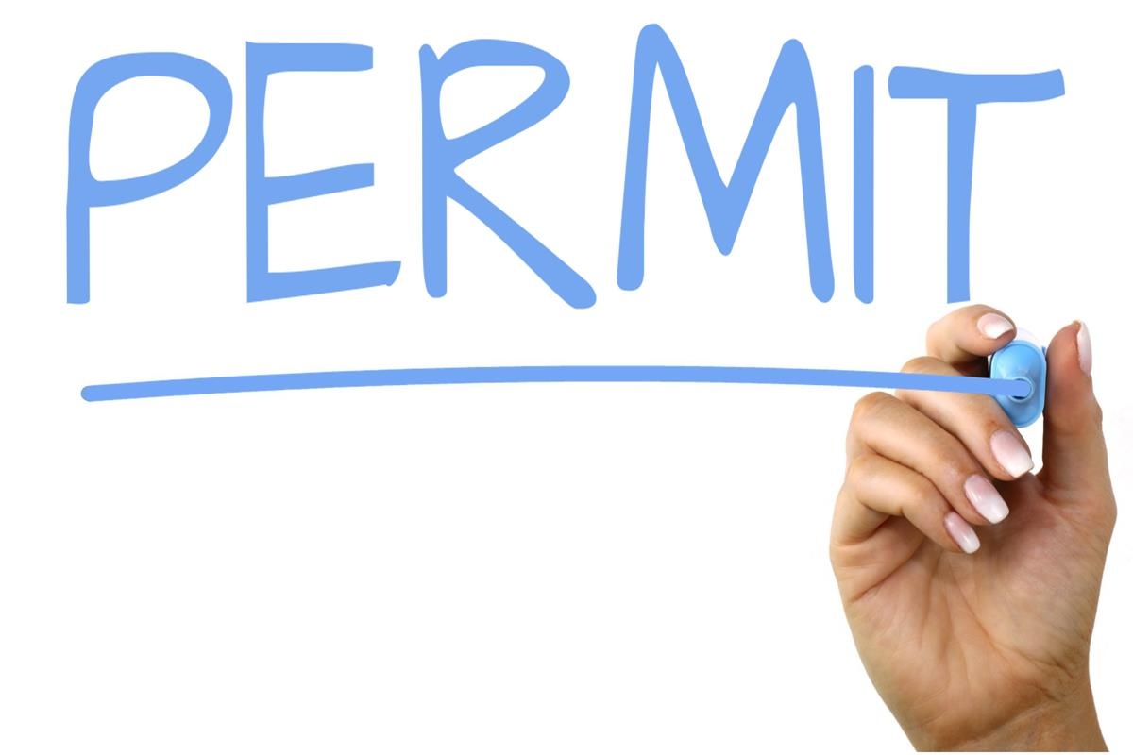

Inspections

Required Inspections
The Building Official, upon the request of the permit holder or their authorized agent, will make the following inspections and will notify the permit holder or their authorized agent of any code violations which must be corrected prior to starting the next phase of construction.

Building
- Foundation inspection: To be made after trenches are excavated and forms erected.
- Pier and curtain wall.
- Floor slab and floor framing.
- Exterior wall before covering.
- Wall tie inspection if brick veneer.
- Frame inspection: To be made after the roof, all framing, fireblocking and bracing is in place, all concealing wiring, all pipes, chimneys, ducts and vents are complete.
- Final inspection: To be made after the building is completed and ready for occupancy.

Electrical
- Underground inspection: To be made after trenches or ditches are excavated, conduit or cable installed, and before any backfill is put in place.
- Rough-In inspection: To be made after the roof, framing, fireblocking and bracing is in place and prior to the installation of wall or ceiling membranes.
- Final inspection: To be made after the building is complete, all required electrical fixtures are in place and properly connected or protected, and the structure is ready for occupancy.

Plumbing
- Underground inspection: To be made after trenches or ditches are excavated, piping installed, and before any backfill is put in place.
- Rough-In inspection: To be made after the roof, framing, fireblocking and bracing is in place and all soil, waste and vent piping is complete, and prior to this installation of wall or ceiling membranes.
- Final inspection: To be made after the building is complete, all plumbing fixtures are in place and properly connected, and the structure is ready for occupancy.
NOTE: See Section P312 of the Standard Plumbing Code for required tests.

Mechanical
- Underground inspection: To be made after trenches or ditches are excavated, underground duct and fuel piping installed, and before any backfill is put in place.
- Rough-In inspection: To be made after the roof, framing, fire blocking and bracing are in place and all ducting, and other concealed components are complete, and prior to the installation of wall or ceiling membranes.
- Final inspection: To be made after the building is complete, the mechanical system is in place and properly connected, and the structure is ready for occupancy.

Gas
- Rough piping inspection: To be made after all new piping authorized by the permit has been installed, and before any such piping has been covered or concealed or any fixtures or gas appliances have been connected.
- Final piping inspection: To be made after all piping authorized by the permit has been installed and after all portions which are to be concealed by plastering or otherwise have been so concealed, and before any fixtures or gas appliances have been connected. This inspection shall include a pressure test.
- Final inspection: To be made on all new gas work authorized by the permit and such portions of existing systems as may be affected by new work or any changes, to insure compliance with all the requirements of this code and to assure that the installation and construction of the gas system is in accordance with reviewed plans.

Other Helpful Information
- The Planning/Zoning Department can assist you in determining if the intended use of the structure is permitted within the requested zoning area. Call (843)464-5661 or 5660 for assistance.
- The size and intended use of the proposed structure will determine the requirement for extensive drawings.
- Allow 14 days for commercial projects and 2 days for residential projects for initial plan review after submission to the Planning Department. Preliminary drawings are encouraged.
- The building permit fee is based on total cost and is paid prior to the issuance of the building permit. The plan review fee is one-half the cost of the permit fee.
- It is important that contractors understand that it is their responsibility to call and request required inspections.
- The contractor should call (843)464-5660, at specified intervals, for required inspections. Requested inspections will be conducted within 48 hours of the request.

.
As a homeowner can I be my own contractor and do I need a building permit?

Homeowners
As a homeowner, you can be your own contractor, as long as you comply with state law.
But before you do anything, call the Building Codes Office (843-464-5660) to see if a permit is required before beginning any work.
Permits are required if you, as the homeowner, or your authorized agent (your contractor), intend to:
- Construct, enlarge, alter, repair, move, demolish or change the occupancy of a building or structure or
- Build, install, enlarge, alter, repair, remove, convert, or replace any electrical, gas, mechanical, or plumbing system
South Carolina state law requires work to be performed by an appropriately licensed contractor. A homeowner may act as their own contractor as long as they are in compliance with South Carolina state law (40-59-260). The state law exception will require that a homeowner’s disclosure statement be completed with the Marion County Clerk of Court office and submitted along with the permit application.

Why are permits needed?
The reason for the permits is a simple one. It is to ensure adequate maintenance of buildings and to adequately protect the health, safety, and welfare of the people and to ensure compliance with the applicable regulations. The codes are ever changing and sometimes a homeowner may not be aware of these changes. We ensure that the work is performed properly and meets standards.

What information do I need to provide the City in order to obtain a building permit?
- The proper forms must be completed and construction plans provided before a permit is issued.
- You will need to list any and all sub-contractors that will be required to complete the project.
- You will need the total cost of the project (i.e., cost of materials and labor).
When must I pull a permit and how long does it take for a building permit to be approved?
- A permit is required for most work / improvements. This excludes some interior remodeling including:
  - Cabinets
  - Countertops
- Note: If new cabinets or countertops involve changes in electric, plumbing or HVAC, you must get a permit.
  - Carpeting
  - Doors
  - Painting
  - Papering
  - Tiling
  - Similar finish work
- Approval time depends on the type of permit you're requesting. Permit applications that require plans to be reviewed will take longer to review before issuing.
How long is a permit good for?

- A permit is good for 180 days from the date of issue. An extension may be granted if the owner or contractor can provide a reason why the extension is warranted.

As a business owner or rental property owner can I be my own general contractor?
- Commercial: For non-residential projects, work performed by the owner is limited to nonstructural and non-mechanical portions of the project.
- Residential: No. Per Section 40-11-360(5) of the Contractors' Licensing Act states an owner may perform the work himself provided that the structure, or appurtenances, including the improvements, are intended for the owner's sole occupancy or occupancy by his or her family and not intended for sale or rent and the general public does not have access to the structure.

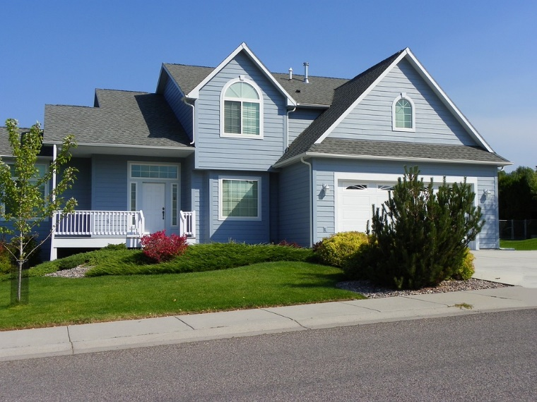
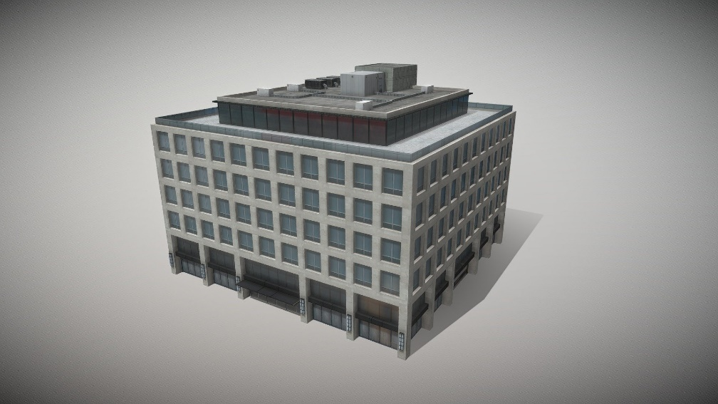

Commercial
Residential
Commercial buildings are buildings where commercial activities take place. Commercial buildings include office buildings, retail space, warehouses and more. This differs somewhat from commercial property, which also includes multi-family buildings like apartment buildings.
Definition of Residential Building All buildings intended for private occupation, whether permanent or temporary, are classified as residential buildings. Single-family, mobile, cottage, semi-detached, row home, and apartment building are the different types of dwellings.

